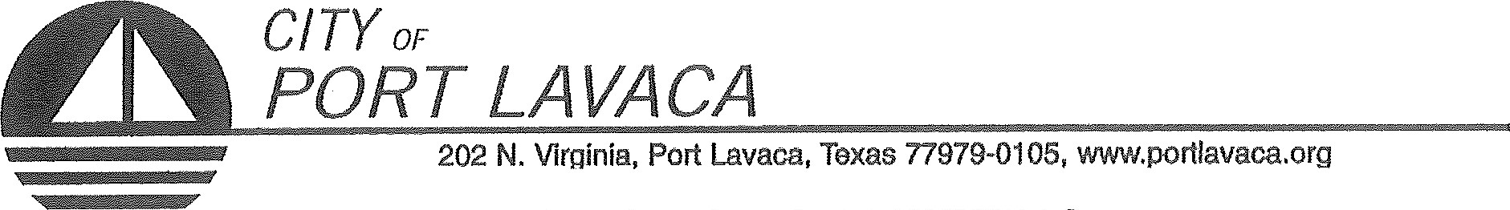
PUBLIC NOTICE OF MEETING
PUBLIC NOTICE IS HEREBY GIVEN THAT THE PORT COMMISSION OF THE CITY OF PORT LAVACA TEXAS WILL HOLD ITS REGULAR MEETING TUESDAY, NOVEMBER 19, 2019 BEGINNING AT 10:00 A.M. AT THE REGULAR MEETING PLACE IN COUNCIL CHAMBERS IN CITY HALL, 202 NORTH VIRGINIA STREET, PORT LAVACA, TEXAS TO CONSIDER AND TAKE ACTION ON THE FOLLOWING ITEMS OF BUSINESS:
- CALL TO ORDER
- COMMENTS FROM THE PUBLIC
(Limited to 3 minutes per individual unless permission to speak longer is received in advance)
AGENDA: (PORT COMMISSION WILL CONSIDER/DISCUSS THE FOLLOWING ITEMS AND TAKE ANY ACTION ON ANY OF THE BELOW ITEMS AS DEEMED NECESSARY.)
- CONSENT AGENDA:
  - MINUTES OF SPECIAL MEETING OCTOBER 24, 2019
- REPORTS
  - TARIFF REPORT
  - ACCOUNT AGING REPORT
  - REVENUE AND EXPENDITURE REPORT
  - BALANCE SHEET
  - PAYMENT REPORT
- RECEIVE REPORTS FROM STAFF REGARDING CITY HARBOR REPAIRS AND LEASES.
- DISCUSS EVELYN’S LEASE AND LEASING.
- RECEIVE REPORTS FROM STAFF REGARDING THE STATUS OF NAUTICAL LANDINGS BUILDING AND LEASES.
- RECEIVE REPORTS FROM STAFF REGARDING THE STATUS OF NAUTICAL LANDINGS MARINA, REPAIRS TO MARINA, MARINA LEASES AND RATE INCREASES.
- DISCUSS DOCK B AT NAUTICAL LANDINGS.
- RECEIVE REPORT FROM STAFF REGARDING SMITH HARBOR, ASSOCIATED PROPERTIES, AND LEASES.
- RECEIVE PRESENTATION FROM GULF HYDROGRAPHIC AND COASTAL CONSULTING REGARDING SMITH HARBOR CLEAN UP AND IMPROVEMENTS.
- RECEIVE REPORTS FROM STAFF REGARDING HARBOR OF REFUGE AND LEASES.
- DISCUSS BULKHEAD REPAIRS AT HELENA CHEMICAL.
- GENERAL COMMENTS FROM COMMISSIONERS.
ADJOURN

ALEX DAVILA, CHAIRMAN
PORT COMMISSION

CERTIFICATION OF POSTING NOTICE
THIS IS TO CERTIFY THAT THE ABOVE NOTICE OF A REGULAR MEETING OF THE PORT COMMISSION OF THE CITY OF PORT LAVACA TO BE HELD TUESDAY, NOVEMBER 19, 2019. BEGINNING AT 10:00 A.M., WAS POSTED AT CITY HALL, EASILY ACCESSIBLE TO THE PUBLIC, AS OF 5:00 PM, FRIDAY, NOVEMBER 15, 2019.
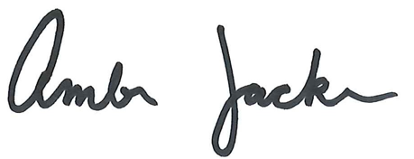

BY: ________________________________________________
AMBER JACKSON
ADMINISTRATIVE ASSISTANT
The Port Lavaca City Hall and Council Chambers are wheelchair accessible. Access to the building is available at the primary north entrance facing Mahan Street. Special parking spaces are located in the Mahan Street parking area. In compliance with the Americans with Disabilities Act, the City of Port Lavaca will provide for reasonable accommodations for persons attending Port Commission meetings. To better serve you, request should be received 24 hours prior to the meetings. Please contact City Secretary Mandy Grant at (361) 552-9793 Ext. 230 for assistance.

