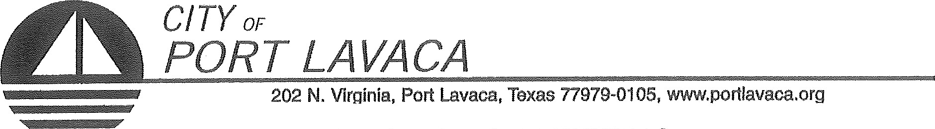
PUBLIC NOTICE OF MEETING
PUBLIC NOTICE IS HEREBY GIVEN THAT THE PORT COMMISSION OF THE CITY OF PORT LAVACA TEXAS WILL HOLD ITS REGULAR MEETING TUESDAY, MAY 15, 2018 BEGINNING AT 10:00 A.M. AT THE REGULAR MEETING PLACE IN COUNCIL CHAMBERS IN CITY HALL, 202 NORTH VIRGINIA STREET, PORT LAVACA, TEXAS TO CONSIDER AND TAKE ACTION ON THE FOLLOWING ITEMS OF BUSINESS:
- CALL TO ORDER
- COMMENTS FROM THE PUBLIC
(Limited to 3 minutes per individual unless permission to speak longer is received in advance)
AGENDA: (PORT COMMISSION WILL CONSIDER/DISCUSS THE FOLLOWING ITEMS AND TAKE ANY ACTION INCLUDING CALLING FOR A CLOSED SESSION ON ANY OF THE BELOW ITEMS AS DEEMED NECESSARY.)
- CONSENT AGENDA:
  - MINUTES OF REGULAR MEETING APRIL 17, 2018.
  - MINUTES OF BUDGET MEETING MAY 8, 2018.
- REPORTS
  - TARIFF REPORT
  - ACCOUNT AGING REPORT
  - REVENUE AND EXPENDITURE REPORT
  - BALANCE SHEET
  - PAYMENT REPORT
- RECEIVE REPORTS FROM STAFF REGARDING CITY HARBOR AND TAKE ANY ACTION DEEMED NECESSARY.
- DISCUSS MILLER LEASE AND TAKE ANY ACTION DEEMED NECESSARY.
- RECEIVE REPORTS FROM STAFF REGARDING THE STATUS OF NAUTICAL LANDINGS MARINA AND BOATS. DISCUSS AND/OR TAKE ANY ACTIONS NECESSARY.
- RECEIVE REPORTS FROM STAFF REGARDING NAUTICAL LANDINGS BUILDING. DISCUSS AND/OR TAKE ANY ACTIONS NECESSARY.
- DISCUSS BELFOR INVOICES. TAKE ANY ACTION NECESSARY.
- DISCUSS LEASED AND UNLEASED PROPERTIES AT HARBOR OF REFUGE AND TAKE ANY ACTION NECESSARY.
- DISCUSS PROPERTIES AND PURCHASING AND TAKE ANY ACTION NECESSARY.
- ANNOUNCEMENT BY CHAIRMAN THAT PORT COMMISSION WILL RETIRE INTO CLOSED SESSION: FOR DELIBERATION REGARDING ECONOMIC DEVELOPMENT NEGOTIATION IN ACCORDANCE WITH CHAPTER 551, TITLE 5. SECTION 551.087 OF THE TEXAS GOVERNMENT CODE.
- RETURN FROM CLOSED SESSION. DISCUSS AND TAKE ANY ACTION NECESSARY.
- RECEIVE ANY OTHER REPORTS FROM STAFF REGARDING HARBOR OF REFUGE.
- DISCUSS AND TAKE NECESSARY ACTION ON HELENA CHEMICAL HARBOR OF REFUGE LEASE.
- APPOINT NEW SECRETARY OF PORT COMMISSION.
- GENERAL COMMENTS FROM COMMISSIONERS AND REVIEW TO DO LIST.
ADJOURN

ALEX DAVILA, CHAIRMAN
PORT COMMISSION

CERTIFICATION OF POSTING NOTICE
THIS IS TO CERTIFY THAT 'THE ABOVE NOTICE OF A REGULAR MEETING OF THE PORT COMMISSION OF THE CITY OF PORT LAVACA TO BE HELD TUESDAY, MAY 15, 2018. BEGINNING AT 10:00 A.M., WAS POSTED AT CITY HALL, EASILY ACCESSIBLE TO THE PUBLIC, AS OF 5:00 PM, FRIDAY, MAY 11, 2018.
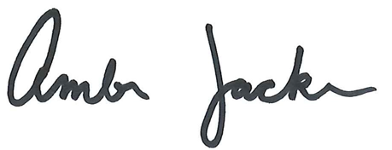

BY: ________________________________________________
AMBER JACKSON
ADMINISTRATIVE ASSISTANT
The Port Lavaca City Hall and Council Chambers are wheelchair accessible. Access to the building is available at the primary north entrance facing Mahan Street. Special parking spaces are located in the Mahan Street parking area. In compliance with the Americans with Disabilities Act, the City of Port Lavaca will provide for reasonable accommodations for persons attending Port Commission meetings. To better serve you, request should be received 24 hours prior to the meetings. Please contact City Secretary Mandy Grant at (361) 552-9793 Ext. 230 for assistance.

