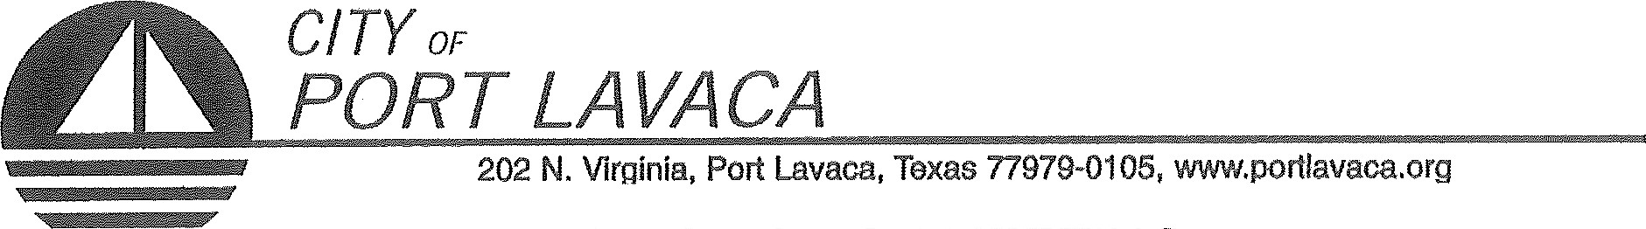
PUBLIC NOTICE OF MEETING
PUBLIC NOTICE IS HEREBY GIVEN THAT THE CITY COUNCIL AND PORT COMMISSION BOARD OF THE CITY OF PORT LAVACA TEXAS WILL HOLD A JOINT WORKSHOP SESSION MONDAY, APRIL 30, 2018 BEGINNING AT 5:30 P.M. IN THE TRAINING ROOM AT NAUTICAL LANDINGS BUILDING, 106 S COMMERCE STREET, SUITE 1-B, PORT LAVACA, TEXAS TO CONDUCT THE FOLLOWING ITEMS OF BUSINESS:

- CALL TO ORDER
  - ANNOUNCEMENT BY MAYOR THAT WORKSHOP SESSION NOW OPEN
- CONDUCT WORKSHOP SEESION:
- REVIEW COMPREHENSIVE PLAN AND PORT OPERATIONS.
ADJOURN

JACK WHITLOW, MAYOR

CERTIFICATION OF POSTING NOTICE
THIS IS TO CERTIFY THAT 'THE ABOVE NOTICE OF JOINT WORKSHOP SESSION OF THE CITY COUNCIL AND PORT COMMISSION OF THE CITY OF PORT LAVACA TO BE HELD MONDAY, APRIL 30, 2018 BEGINNING AT 5:30 P.M., WAS POSTED AT CITY HALL, EASILY ACCESSIBLE TO THE PUBLIC, AS OF 5:00 PM, APRIL 26, 2018.
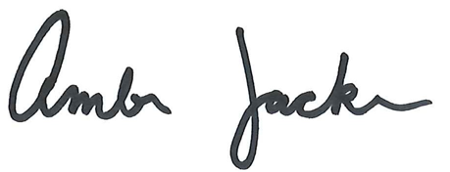

BY: _________________________________________________
AMBER JACKSON
ADMINISTRATIVE ASSISTANT
The Port Lavaca City Hall and Council Chambers are wheelchair accessible. Access to the building is available at the primary north entrance facing Mahan Street. Special parking spaces are located in the Mahan Street parking area. In cornpliance with the Americans with Disabilities Act, the City of Port Lavaca will provide för reasonable accommodations for persons attending Port Commission meetings. To better serve you, request should be received 24 hours prior to the rneetings. Please contact City Secretary Mandy Grant at (361) 552-9793 Ext. 23() for assistance.

